Github Version Screenshots Evidence

|  |  |
| --- | --- |
|  | Ver 1.0 |
|  | Ver2.0 |
|  | Ver3.0 |
|  | Ver4.0 |
|  | Ver5.0 |
|  | Ver6.0 |
|  | Ver7.0 |
|  | Ver8.0 |

Here I have screenshots showing some of the way in which I organised my GitHub repository. 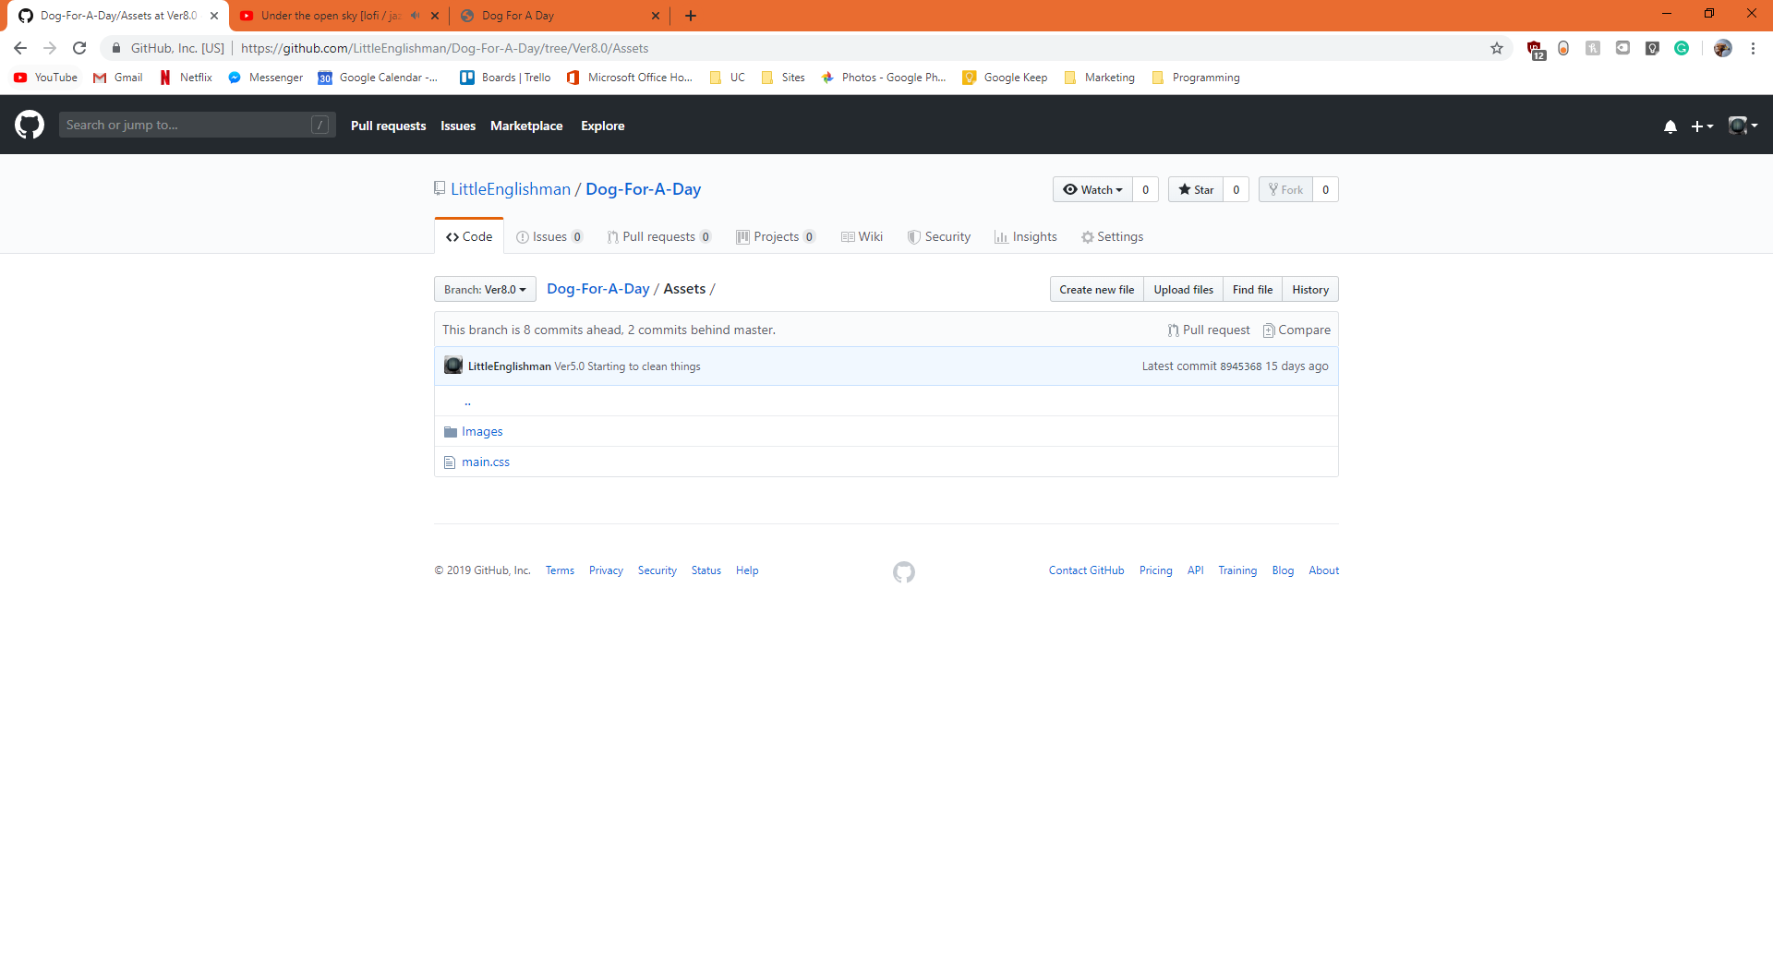

This first screenshot shows the assets folder which held all the assets of the webpage such as images and css into one folder.

Here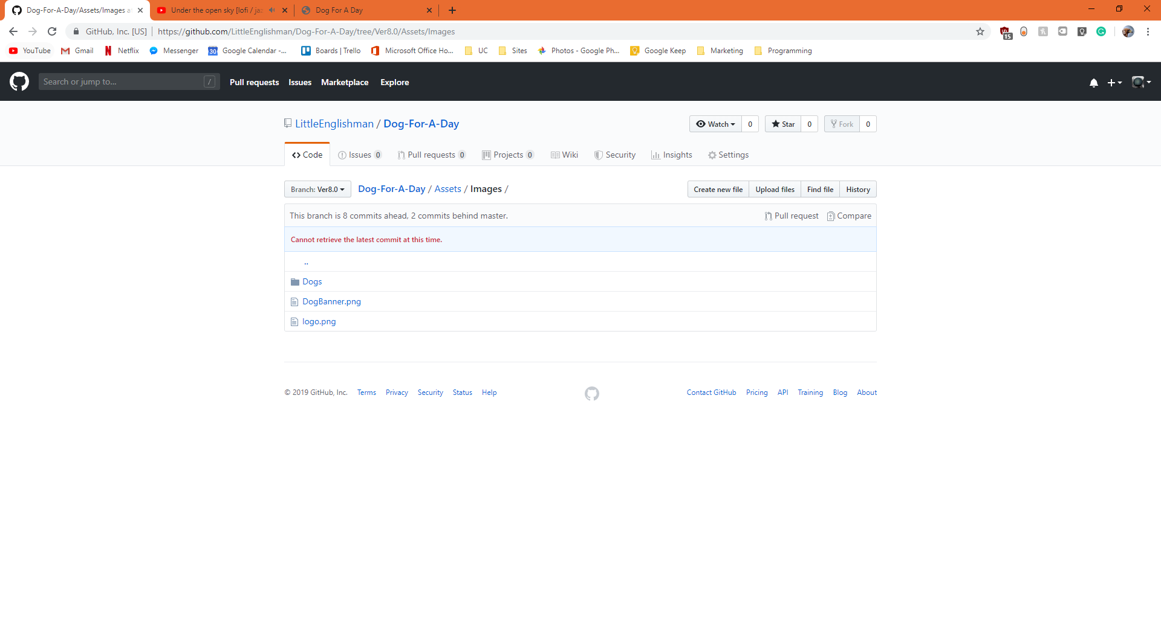

This shows the images folder where I have another section for dog images and the banner web images as well.

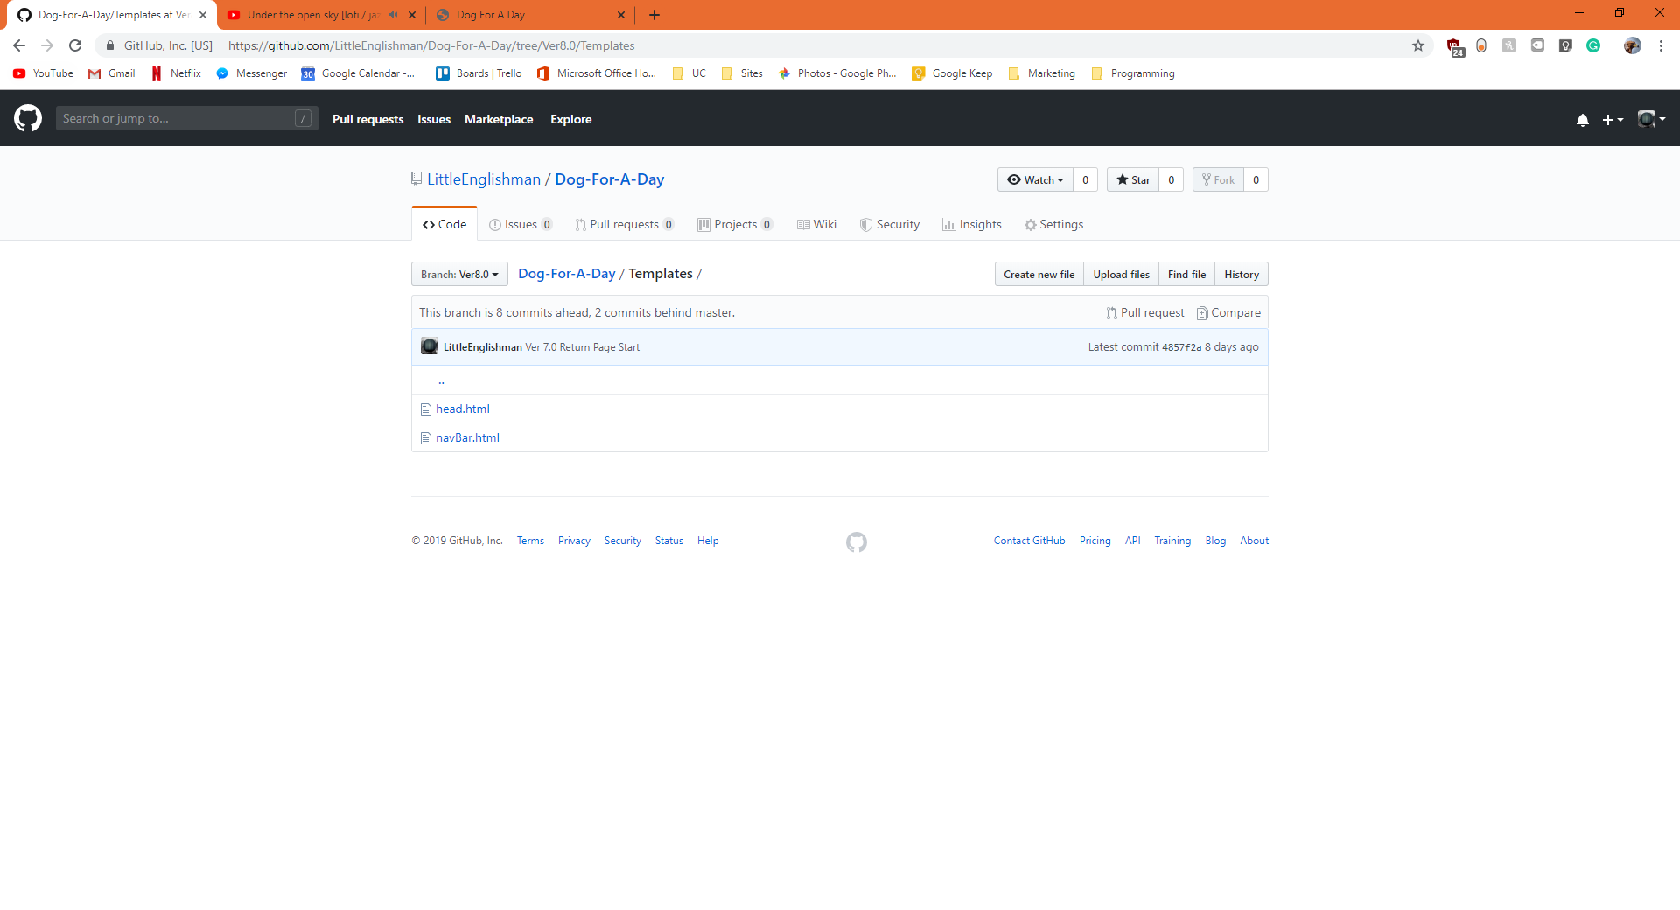

Here you can see the templates which I used within my web-page to make it quicker. I could easily edit the top nav bar in one file to make that change to my whole webpage. This made creating the website much easier and faster, as well as more robust.